**SEO Master:**

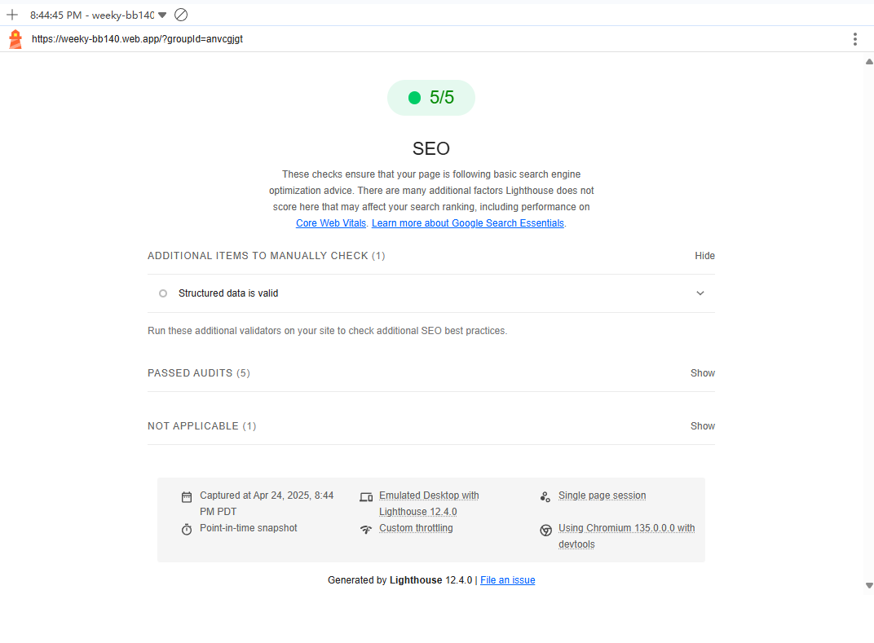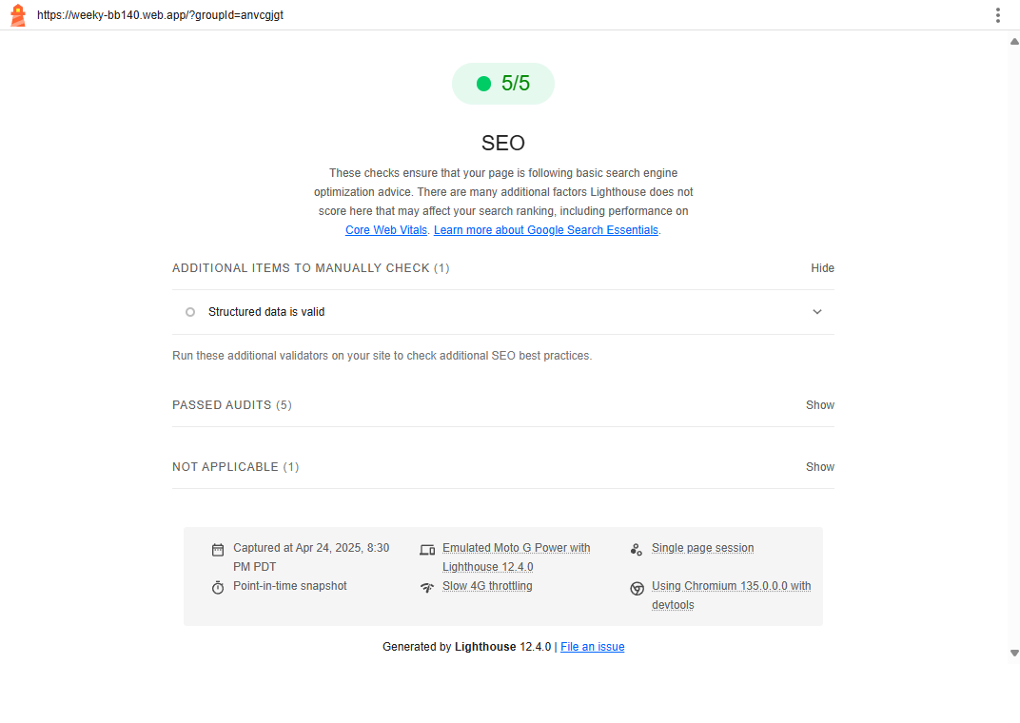

**Accessibility master:**

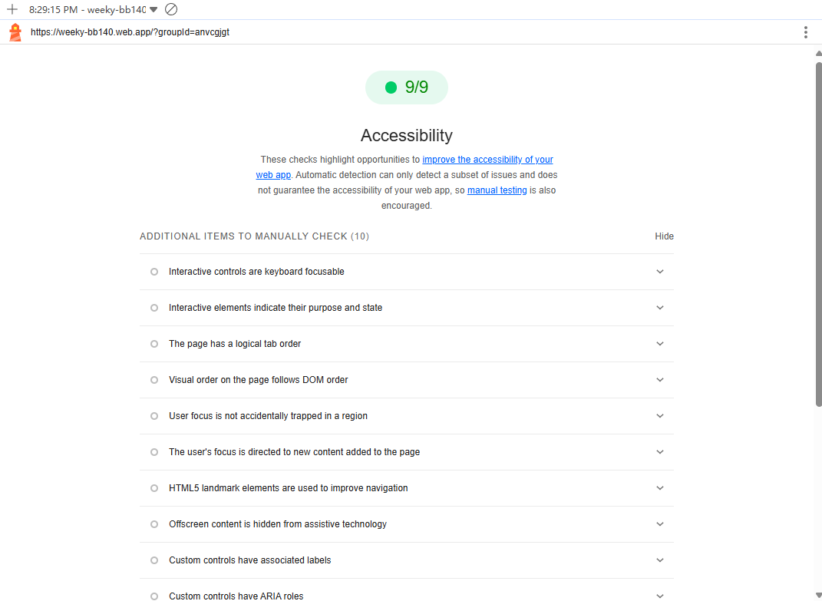

**CSS master:**

**1. position: fixed – Floating Action Button (FAB) Placement**

Purpose: This technique is used to position the action menu (.fab-container) at the bottom-right corner of the screen, regardless of scrolling.

Justification: Keeping essential actions like "Submit", "Clear", and "Share" always visible improves user experience and accessibility, especially on long-scroll pages.

文本

AI 生成的内容可能不正确。

**2. box-shadow – Visual Depth and Interactivity**

Purpose: Adds depth to the floating action button, creating a modern and visually engaging interface.

Justification: The shadow effect makes the button stand out against the background, signaling that it is interactive and important.

文本

AI 生成的内容可能不正确。

**3. transition – Smooth Visual Feedback**

Purpose: Applies smooth transitions to background color and transform effects on buttons and menus.  
Justification: Enhances interactivity and professionalism by avoiding abrupt changes. This is especially noticeable on hover or when expanding the FAB menu.

文本

AI 生成的内容可能不正确。

**Delightful design:**

1. **Visual Design & Professional Aesthetic**

1.1 Color Usage

* Distinct color-coding for functional clarity:
  + Purple (#6c5ce7): Primary actions (navigation, FAB)
  + Red (#e74c3c): Clear/remove actions
  + Green (#27ae60): Select all
  + Blue (#3498db): Sharing link
* Heatmap Gradient (from #fff3e0 to #e65100, 10 steps) provides a visual cue for time blocks with the highest user overlap, guiding optimal meeting time selection.

1.2 Typography

* Consistent use of modern, sans-serif fonts (e.g., Roboto, Segoe UI) for clean readability​index.
* Clear text hierarchy:
  + Page titles: 24px, bold, centered
  + Day labels: 14px, bold, white text on dark background
  + Time slots: smaller size with hover and active states

1.3 Layout & Spacing

* Grid system ensures perfect alignment across columns (7 days)​
* Responsive max width of 800px for desktop, with auto-centering layout.
* Floating action menu (FAB) fixed to bottom-right for universal accessibility.

1. **User Attention Flow & Hierarchy (Evaluated on Two Pages)**

Page 1: **Main Scheduler Interface**

Attention Flow:

1. Page Title & Navigation Buttons — Users first orient themselves with the current/next week
2. Heatmap Grid — The most attention-grabbing section showing availability density
3. FAB Menu — Gives direct access to all necessary controls: Select All, Clear, Share, Submit

Justification:

* Color-coded cells help users instantly identify optimal slots
* The action menu remains unobtrusive but immediately accessible

Page 2: **FAB Expanded Interface (Actions)**

Attention Flow:

1. Top FAB Buttons — First visible: Select All / Clear
2. Followed by Share & (Re)Submit — Intuitive flow matches user logic

Justification:

* Logical ordering: select time → share → confirm submission
* Visual weight and spatial grouping guide user decisions effectively

**3. Written Explanation of Design Principles**

| **Principle** | **Implementation Example** |
| --- | --- |
| **Contrast** | High-contrast buttons and color-coded heatmap improve clarity and focus |
| **Alignment** | Strict grid-based layout ensures professional alignment across all cells |
| **Proximity** | FAB clusters related actions (select, clear, share, submit) to reduce cognitive load |
| **Hierarchy** | Text size, color intensity, and hover effects create natural visual prioritization |
| **Consistency** | Unified font style, button shapes, interaction patterns across all components |

**Javascript master:**

**1: Heatmap Color Display via Dynamic Class Binding**

Type: React + Data-driven CSS Integration

The application calculates how many users marked each time slot as available, and converts that proportion into a class name (heat-1 to heat-10) for CSS-based heatmap coloring.



**Purpose & Justification:**

* Enables users to visually identify the most popular time slots at a glance.
* Enhances decision-making and supports faster group consensus through intuitive visuals.
* This technique is directly tied to the app’s collaborative goal.

**2: One-Click Link Sharing via Clipboard API**

Type: Native Browser API (not taught in class)

Implements link copying using navigator.clipboard.writeText() to allow seamless link sharing between users.

文本

AI 生成的内容可能不正确。

**Purpose & Justification:**

* Greatly improves the sharing experience by removing manual copy-paste.
* Critical for group-based collaboration since users must join via shared links.
* Includes a fallback using window.prompt() for maximum compatibility.

**3: Dynamic Date & Time Logic**

Type: Native JavaScript Date Object Usage

Description:

Automatically calculates the start of the week, maps each cell to a real timestamp, and prevents users from selecting past time slots.

文本

AI 生成的内容可能不正确。

**Purpose & Justification:**

* Supports week navigation and time-based validation.
* Prevents outdated selections, ensuring data relevance and logic accuracy.
* Directly tied to the app’s core scheduling functionality.